Labaratory Work 1
Task1.1:
1)Superkeys: {EmpID}, {SSN}, { EmpID, Name}, { Email}, {EmpID, Department, Salary}, {EmpID, SSN, Email, Phone, Name, Department, Salary}
2) all candidate keys : {EmpID}, {SSN}, { Email}, {Phone}
3) candidad key as primary key: {EmpID}, Because it is an artificial numeric identifier (surrogate key), has a fixed length, contains no sensitive personal data (unlike an SSN), and never changes (unlike an email address or phone number).
4)One phone number for two employees: Based on the available data (Sample Data) — no, because all three employees have different phone numbers. However, from a real-world , two employees might share the same work or home phone number if there is no UNIQUE constraint on that field in the database. In this data two employees can not have the same phone number.
RELATION B:
1) {StudentID, CourseCode, Section, Semester, Year}
2) StudentID: Uniquely identifies the student enrolling in a course.
CourseCode: Identifies the specific subject/course being taken.
Section: Identifies the specific class group/section for that course, as a course can have multiple sections.
Semester & Year: Allow a student to retake or enroll in the same course again in different terms without violating database constraints (Business Rule 1).
Summary: Together, these 5 attributes ensure that a student cannot register for the exact same section of a course twice in the same semester (Business Rule 2).
3) No additional candidate keys exist. The remaining attributes (Grade and Credits) are dependent non-key attributes and cannot uniquely identify a row

TASK 1.2
1)Identify all foreign key relationships:
{studentID}, {Name}, {CourseID}, {chairID}, {ProfID}, {AdvisorID}

Part2: 1. Identify Entities (Strong vs. Weak)
Strong Entities (Сильные сущности):
Patient (PatientID),Doctor (DoctorID),Department (DeptCode)
Weak Entity (Слабая сущность): Hospital room

2. Identify Attributes & Types
Patient
- PatientID — Simple, Primary Key
- Name — Simple (или Composite: First, Last)
- Birthdate — Simple
- Address — Composite (Street, City, State, Zip)
- Phone Number — Multi-valued (One patient can has some numbers)
- Insurance Info — Simple
- Doctor
    - DoctorID — Simple, Primary Key
    - Name — Simple
    - Specialization — Multi-valued (может иметь несколько специализаций)
    - Phone Number — Simple
    - Office Location — Simple
Department
- DeptCode — Simple, Primary Key
- Name — Simple
- Location — Simple
Hospital Room
- RoomNumber — Partial Key (Discriminator)
Appointment(встреча)
- AppointmentID — Primary Key
- DateTime — Simple
- Purpose — Simple
- Notes — Simple
Prescription(рецепт)
- PrescriptionID — Primary Key
- Medication(медикамент) — Simple
- Dosage(дозировка) — Simple
- Instructions — Simple

3. Relationships and Cardinalities
- Department — Hospital Room: 1:N (Одно отделение содержит много комнат; комната принадлежит 1 отделению).
- Patient — Appointment: 1:N (Один пациент может иметь много записей).
- Doctor — Appointment: 1:N (Один врач может иметь много записей на прием).
- Doctor — Prescription — Patient: M:N (или через 1:N от Doctor/Patient к Prescription) — Врач выписывает много рецептов пациенту, пациент может получать рецепты от разных врачей.
- Doctor — Department: N:1 (Врач работает в одном отделении, в отделении работает много врачей).
- Patient — Doctor: M:N

4) Draw the complete ER diagram using proper notation.
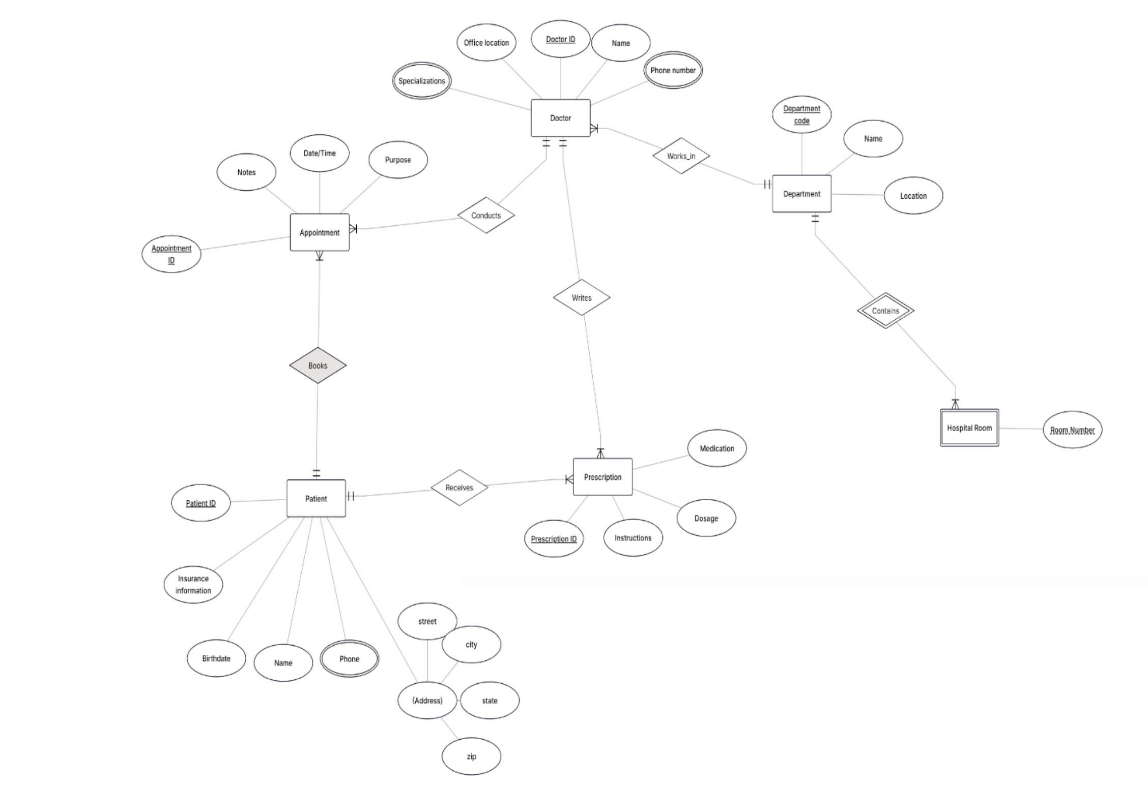

5) 5. Primary Keys
- Patient: PatientID
- Doctor: DoctorID
- Department: DeptCode
- Appointment: AppointmentID
- Prescription: PrescriptionID

TASK 2.2

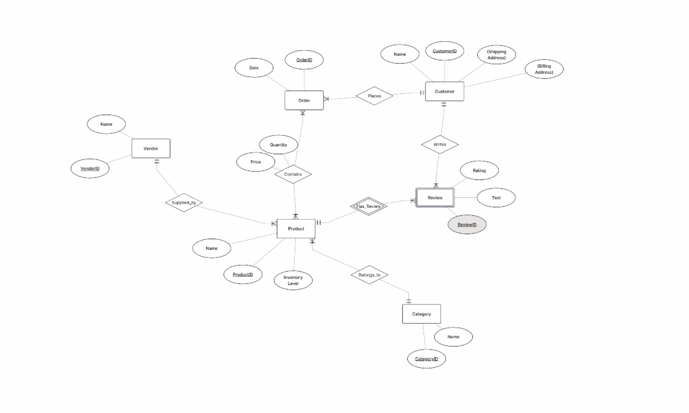

Part 4: Normalization Workshop

Task 4.1: Denormalized Table Analysis
1. Functional Dependencies
StudentID → StudentName, StudentMajor
ProjectID → ProjectTitle, ProjectType, SupervisorID, StartDate, EndDate
SupervisorID → SupervisorName, SupervisorDept
(StudentID, ProjectID) → Role, HoursWorked

2. Problems
Redundancy: Student and project information is repeated in multiple rows.
Update anomaly: Changing a supervisor's department requires updating multiple rows.
Insert anomaly: A new project cannot easily be added if no student is assigned to it.
Delete anomaly: Deleting the only student assigned to a project may also delete the
project's information.

3. 1NF
The table is already in 1NF because all attributes contain atomic values and there are
no repeating groups.

4. 2NF
Primary Key: (StudentID, ProjectID)
Partial dependencies:
StudentID → StudentName, StudentMajor
ProjectID → ProjectTitle, ProjectType, SupervisorID, StartDate, EndDate
2NF decomposition:
Student(StudentID, StudentName, StudentMajor)
Project(ProjectID, ProjectTitle, ProjectType, SupervisorID, StartDate, EndDate)
StudentProject(StudentID, ProjectID, Role, HoursWorked)

5. 3NF
Transitive dependency:
ProjectID → SupervisorID
SupervisorID → SupervisorName, SupervisorDept
Final 3NF decomposition:
Student(StudentID, StudentName, StudentMajor)
Project(ProjectID, ProjectTitle, ProjectType, SupervisorID, StartDate, EndDate)
Supervisor(SupervisorID, SupervisorName, SupervisorDept)StudentProject(StudentID, ProjectID, Role, HoursWorked)

Task 4.2: Advanced Normalization

1. Primary Key
The primary key is:
(StudentID, CourseID, TimeSlot, Room)
It identifies a student's enrollment in a specific course section.

2. Functional Dependencies
StudentID → StudentMajor
CourseID → CourseName
InstructorID → InstructorName
(TimeSlot, Room) → Building
(CourseID, TimeSlot, Room) → InstructorID

3. BCNF
The table is not in BCNF because several determinants are not superkeys.
For example:
StudentID → StudentMajor
StudentID does not uniquely identify a row in the original table.

4. BCNF Decomposition
Student(StudentID, StudentMajor)
Course(CourseID, CourseName)
Instructor(InstructorID, InstructorName)
RoomSchedule(TimeSlot, Room, Building)
CourseSection(CourseID, TimeSlot, Room, InstructorID)
Enrollment(StudentID, CourseID, TimeSlot, Room)

5. Information Loss
The decomposition is lossless. The original information can be reconstructed using joins
between the tables. No actual information is lost, but retrieving the complete information
requires several joins.

Part 5: Design Challenge
Task 5.1: Real-World Application

1. ER DiagramMain entities:
Student
Club
Faculty
Membership
OfficerPosition
ClubOfficer
Event
Attendance
Room
Budget
Expense
Main relationships:
Student ↔ Club — M:N
Club → Event — 1:N
Student ↔ Event — M:N
Faculty → Club — 1:N
Club → Room/Event — 1:N
Club → Expense — 1:N
Club → Budget — 1:N

2. Relational Schema
Student(StudentID PK, StudentName, StudentEmail, StudentMajor)
Faculty(FacultyID PK, FacultyName, FacultyEmail, Department)
Club(ClubID PK, ClubName, Description, FoundedDate, AdvisorID FK)
Membership(StudentID PK/FK, ClubID PK/FK, JoinDate, MembershipStatus)
OfficerPosition(PositionID PK, PositionName)
ClubOfficer(StudentID PK/FK, ClubID PK/FK, PositionID PK/FK, StartDate, EndDate)
Room(RoomID PK, RoomNumber, Building, Capacity)
Event(EventID PK, ClubID FK, EventName, EventDate, StartTime, EndTime,
Description, RoomID FK)
Attendance(StudentID PK/FK, EventID PK/FK, AttendanceStatus)Budget(BudgetID PK, ClubID FK, FiscalYear, Amount)
Expense(ExpenseID PK, ClubID FK, ExpenseDate, Amount, Description, Category)

3. Design Decision
I chose to create a separate OfficerPosition table instead of storing positions directly in
Membership.
This makes the system more flexible because new positions can be added without
changing the database structure.

4. Example Queries
Find all students who are officers in the Computer Science Club.
List all events scheduled for next week with their room reservations.
Show each club's total expenses and remaining budget.

